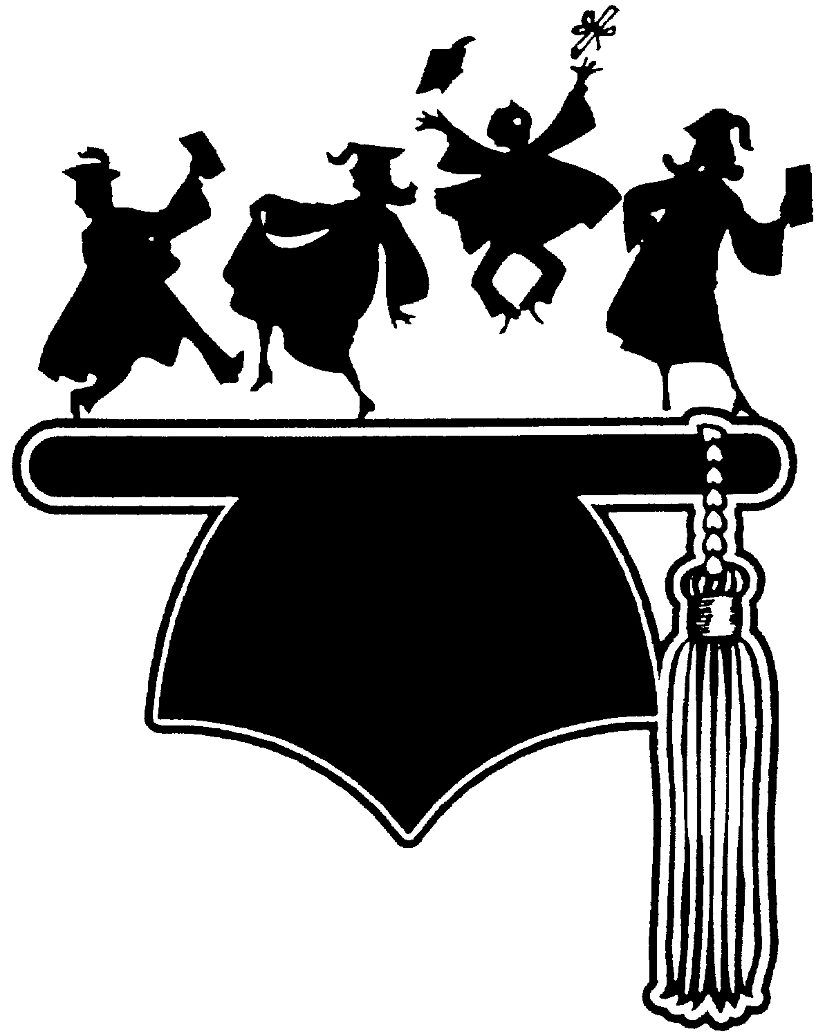
Project Graduation-
Amphitheater High School
A Safe and Sober Grad Night celebration

- Project Graduation is an alcohol and drug free all-night graduation celebration for seniors.

- Graduation night can be the most dangerous night of the year for teens, according to law enforcement statistics.

- Grad Night celebrations are a safe alternative to the dangerous tradition of party hopping the night of graduation, which often involves drinking and driving.

- This program was developed by the U.S. Department of Transportation and a National Grad Night Network over twenty years ago, and is highly successful with teens in other cities.

- In communities across the nation where this program has become a tradition, attendance has exceeded 90% of the graduating senior classes.

- Our parent organizations are working closely with the Tucson Police Chief to make this an annual event.

- Graduates will enjoy a night of food, music, a casino night, games, prizes, dancing, hot tubs, surprise entertainment and more.

- Hundreds of parents, local volunteers, law enforcement officials, retirees, etc. will be planning and conducting this event.

- Local businesses, community volunteers and parents forge a tangible partnership to save kids lives each year.

- The saving of just one life is priceless – it could be the life of your teen, a grandchild, a niece or nephew, a neighbor’s child, or an employee’s child.

